# Target Metrics

Overall - Accuracy: 0.8200, Precision: 0.8467, Recall: 0.8200, F1: 0.8230

Class-specific metrics:

Carbon neutral(ity) - Precision: 0.7308, Recall: 0.7600, F1: 0.7451

Emissions reduction target - Precision: 0.9500, Recall: 0.7600, F1: 0.8444

Net zero - Precision: 0.7059, Recall: 0.9600, F1: 0.8136

No target - Precision: 1.0000, Recall: 0.8000, F1: 0.8889

# Year Metrics

Overall - Accuracy: 0.8100, Precision: 0.8194, Recall: 0.8100, F1: 0.8117

Class-specific metrics:

2020 - Precision: 0.0000, Recall: 0.0000, F1: 0.0000

2022 - Precision: 0.0000, Recall: 0.0000, F1: 0.0000

2023 - Precision: 0.0000, Recall: 0.0000, F1: 0.0000

2025 - Precision: 0.6000, Recall: 0.6000, F1: 0.6000

2030 - Precision: 0.7500, Recall: 0.8400, F1: 0.7925

2031-32 - Precision: 0.0000, Recall: 0.0000, F1: 0.0000

2032 - Precision: 0.0000, Recall: 0.0000, F1: 0.0000

2035 - Precision: 0.8333, Recall: 1.0000, F1: 0.9091

2040 - Precision: 0.8182, Recall: 0.9000, F1: 0.8571

2050 - Precision: 0.8462, Recall: 0.8148, F1: 0.8302

No target - Precision: 1.0000, Recall: 0.8400, F1: 0.9130

# Other Metrics

Quote Accuracy: 0.9400

Overall Accuracy: 0.7400

Valid XML Percentage: 0.9900

# Confusion Matrices

Target Confusion Matrix:

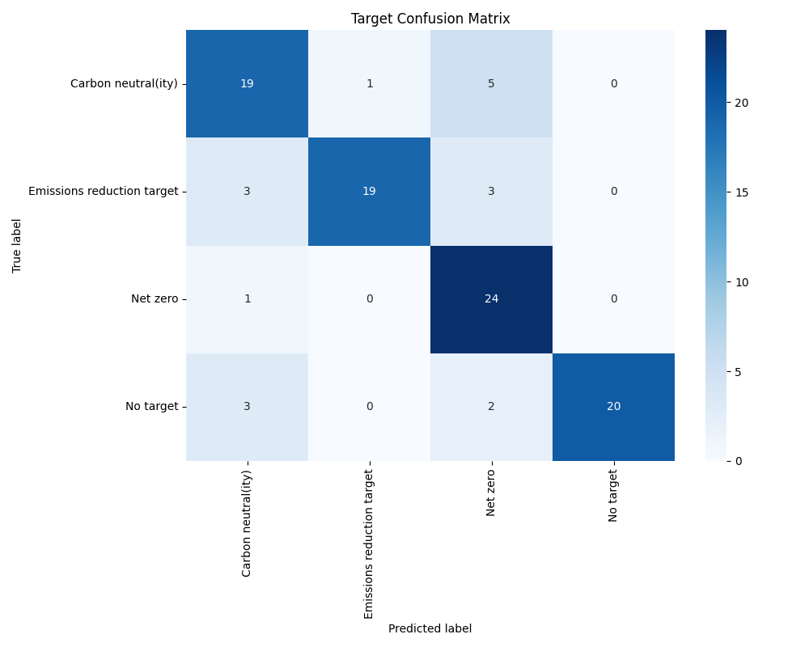

Year Confusion Matrix:

